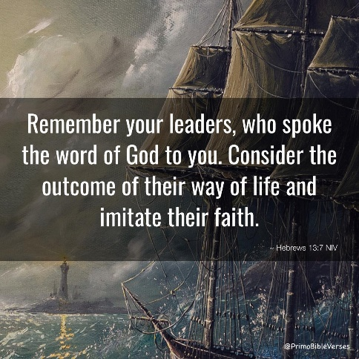
The hallways of our nation’s capital in Washington D.C. are lined with statues. Each state has two statues. North Dakota has John Burke and Sakakawea. Hebrews chapter 11 also has a great hallway of faith filled with living memorials to those who have walked in faith before us.
Hebrews 13:7 says “Remember your leaders, those who spoke the word of God. Consider the outcome of their way of life, and imitate their faith.” In our mid-week Lenten services, we will be doing just that – remembering the faith of our leaders.
We will start with Abel who by faith offered a more acceptable sacrifice than Cain. We will continue with Noah who by faith built an ark for the saving of his household. We will walk with Abraham who by faith “obeyed when he was called to go out to a place that he was to receive as an inheritance.” We will look at Abraham again who by faith offered up his only son yet believing that God could raise him from the dead. We will walk with Joseph who by faith “made mention of the exodus of the Israelites and gave directions concerning his bones.” And we will travel with Moses who by faith choose “rather to be mistreated with the people of God than to enjoy the fleeting pleasures of sin.”
We will remember our leaders so we may “consider the outcome of their way of life and imitate their faith.” Our midweek Lenten services will be Wednesdays at 6:30 pm. Soup and sandwiches will be served at 5:30 pm. Please join us!

